UseCase 5
www.plantuml.com/plantuml/png/ZP91Qy9048Nl-oiUELTx5n75G_5SxQbGjhiJ7MgoOMUYGl2_TpTjJA2N7WBXpJVVlYnPYzgeRNKs6Xfem6TG3HKyHtBAeJR6EWqHnK4e5h22DhqCuMwFHyvgJ6FTbpqIYcseghPcPxD3i6cQ0fr1NdPM4l1ADhfJlotz-c7xyPDDgOttkTHB36qpK2cR8czCLsnFLX-Qd1XZxkd9NJ6RhKOx5ZZoXGHd5aKeaH4nhF_2fhxSRG6ryKZQZvy5DXAiz-G7uL0dpwT1skouX0lr9NdxMyALzJI8w9REbVG9OwFbV3uUkrpIJQdsgzKVOl2Fo7lTxKhiza-uv94qvBXazzjTuDBjtSqwiUb7-0O0

@startuml
top to bottom direction

actor "User" as user
actor "IT User" as it

package "Communications App" {
usecase "Search Users" as UC_Search
usecase "Add to Group" as UC_Add
usecase "View Chats" as UC_View

}

user --> UC_Search : gives list of users
it --> UC_Search : gives list of users
user --> UC_Add : target user/s are added
it --> UC_View
user --> UC_View : {if conversation with user/s exists}

UC_Search <.. UC_Add : <<extend>>
UC_Search <.. UC_View : <<extend>>\n{If IT, view specific targets chat}
@enduml

Better

user
XP91QyCm38NlWVm7aPsxqMjQIajMs63ia91RBswYfWP7xYndM__zf7HqfIlR9HZflKzFTfOSJOX3xz8aJIeCxnXWFbyT3ius9bfFYmKOXcfTfadXB5AyrIvUdjF4DD671wXP45Ahfuea7n6okbf3iP9FBgHLMJo1LCeg6tM5wkefJ2OB1S5TnC-ORzs08Xzfbi7vhiCMB5s9SrXJnC30Q4Ap1pdti253BUnjP43jgaV5QfAvcWAfFNlU1Wp7SN_fNMgqYmm1Eyk2aVa3wwmDxNo0tiHcRwdxxH-tS9Om5yzC3_TRxzhPk9XYSdZr9x_WTtwWzfQv2uXqRH-B0YWn3e7u9yKfcfEab-lALVsJvD7omPaZGoPlDP8-p7Ue37faDXtUuFqPxipKE8hqkr-tg2cNyWpoxtq1

@startuml

Server <<Application>> as SER
Client <<Application>> as CLI
actor/ User as U1

note "USE CASE : SEARCH USERS" as UC

U1 --> CLI #text:blue : User is logged in

U1 --> CLI : Enters search term \nand hits enter

CLI --> SER : Sends search query

SER --> SER : Searches registered users \nfor matching query

SER --> CLI #line:red;line.bold;text:red : No matches found
SER --> CLI #line:green;line.bold;text:green : Returns matching users list

CLI --> U1 #line:red;line.bold;text:red : Displays "nothing was found" message
CLI --> U1 #line:green;line.bold;text:green : Displays listing of registered users

@enduml

User and IT
fPD1Ry8m38NlbVeVB7Pc4zU24AX36jAqGqjlN49hsaWXOKcwZNy_Eunki8fDswMAdEVlFLlfp7bXVRjJSHH7ETeNj32PpFTx9KlXfT7JAGW7-IABerH9rBxlEdrSnf4elR5tK3X2SB4OTRN1SXNg0wulLoCsqyOZ38fy0UcSFWbvpBFq0QYIvH2KHSh2OWJ3uPGzuCRZcqysgaNI1oFfG9cwnWgaZYD2zsi__2_aP-m45jgZTU1GsB81EkzWhOMke97U0VBjkSKlMsXp9EOc6eq7HLrrFSyjsaDOFjsTD6VPyo141nPhwOX8wLl7jckzDHPsmfUDrFLtL5Y3aXeJwXdpuNPZL3KETCOay6IE_OJVcbPNVSsrHTINxQ58W0nzQxNxJ76CfYZfrybfqJyakPTkhyJ10JsC07eLNQOJXPV_3qnFdAkpTIoUXbbcUnolBz5VIN4qe_T0V-0x

@startuml

Server <<Application>> as SER
Client <<Application>> as CLI
actor/ User as U1
actor/ "IT User" as IT1

note "USE CASE : SEARCH USERS " as UC
note "Blue Actions are abstractions." as TODO

U1 --> CLI #text:blue : User is logged in
IT1 --> CLI #text:blue : IT User is logged in

U1 --> CLI : Enters search term \nand hits enter
IT1 --> CLI : Enters search term \nand hits enter

CLI --> SER : Sends search query

SER --> SER #text:blue : Searches registered users \nfor matching query

SER --> CLI #line:red;line.bold;text:red : No matches found
SER --> CLI #line:green;line.bold;text:green : Returns matching users list

CLI --> U1 #line:red;line.bold;text:red : Displays nothing was found
CLI --> IT1 #line:red;line.bold;text:red : Displays nothing was found

CLI --> U1 #line:green;line.bold;text:green : Displays listing of users
CLI --> IT1 #line:green;line.bold;text:green : Displays listing of users

@enduml

UseCase 4
//www.plantuml.com/plantuml/png/RP11ImCn48Nl-HMFlNXgVu2KqD9JGL1OUXCaPeSIt2HBPb8iudytILrPhQUTdNdvvhtPifWasOzAuWI9U8qYqMDmYQou69GoLc92TsHA7GmZbs9kzfJEtsrk9JQR_i92Nckb9cFVp8dGxQFtEJXhAf6ncwOE7meLPGtJ5Ow7UC9ZbkVGUCVzIsd4B4jTRyw4dfWBf-fvbjP1_VyNUWY_c2weJwNky9ISD-c2NSkokyQjwR1QwSN-8Zq4E-Q11XGczeNEwcUEzLelBU2-7C5T7sXzgsiE_eZAYfvi3CEDdtRMsT5onrW_pIszks9oIs78Vlm2

@startuml
top to bottom direction

actor "User" as user
actor "Server" as server <<System>>

package "Communications App" {
usecase "User Log Out\n" as UC_Logout
usecase "Save Session Logs" as UC_SaveLogs
usecase "User Log In\n" as UC_Login
}

' Primary Actor Action
user --> UC_Logout

' Included Use Cases
UC_Logout ..> UC_SaveLogs : <<include>>
UC_Logout ..> UC_Login : <<include>>

' Secondary Actor Action
server --> UC_SaveLogs : logs user exit

@enduml

Better
PlantUML Editor

RP31QiCm38RlVWgjWztAo3KhOIMKCIWKbkK1t4H9Grqxi-InllsaP0ihx68Rw_FdNtecjf7JnHbJOVp429lDTXpTq5WUWYyAi0JLxisKRa3F_rNB_Qkn3OVu28acWMvphSwCyO4HLdMrWt8hImxxmmiSwdTOJKG9njGPhDU5ck2UyOlpeqief0izmU3_rdEezHE9qvm9-8H0G-yX98PZOWxU6CKKbzY2L-XRcfD5_4X831pKh6yMjivcKckdS44OROyo4r7ygcwZaJIC1DPVmME3H3PU9MeNu048cGImd4XzeUlSu76HJMtgJHwnVPgaSfZRrJumnX1lQCcM6lsaI-w7kbi06SviwoEYdttJKPwLBX3gc2BQrdm3

@startuml

Server <<Application>> as SER
Client <<Application>> as CLI
actor/ user <<user>> as U1

note "USE CASE : LOG OUT " as UC

U1 --> CLI #text:blue : logs in
U1 --> CLI : User Clicks the sign out button

CLI --> SER : Sends user request to log out
CLI --> U1: Send to home page

SER --> SER #text:blue : stores any necessary info & sets status to offline
SER --> CLI #line:red;text:red : logout error
SER --> CLI : Successful logout!
SER --> U1 #line:green;text:green : Closes thread

Class diagrams

GUI Class diagram
//www.plantuml.com/plantuml/png/dLLFQzm-4BtxK-ZsS_8ZItljASlc3uOs3UmcFPHI57dM5fKbTpHU4qg_UwMnDvQtBWs54CL-p_FqtaYJIqyIgMjCPc1FWfn0NTKaIesWI3kRPVy9i5q3AEEZp-A3E6ZejoG9VcH2l7ULjc5LjQImtABhsWq2yyDpiTiuI-ZClRHWif-nukr38HgfhL16Uf_nRx4n6Yn5A5Qz4Af314ki8zvDcYduu043nildDwlLso-C5kszGmh0bb3RAhmBF_zF2la9uOnXpcBTjaOhtdn-5cMTBWUqrwJgHmrzxiSjFHRNdxvkT-lTzOnP0MscxN6L-0TZfVQjaSyX4Zi4V8teS5BYU7ptD2G3nsmuuwWzPjDvG2iRkD5WoiHdWDh0xnsM9r2gFZScYQ1fYIKOUNBECA8CIEGw_YIBslMyyG_WlQmWRuPr2ZJnCtQtblJn01Zaeu-nnSwILEIF7JmVsXTUwGE4Z0BVSoj2kL7gXJHA5hRjwDLUZPFbPXIT8wu5cohc9B42AgvIJqa2OCkZ-UW2B2qJ4HG4Co_anbUJcHbJ6Qs-XIwuZlBVyqklLNeIglZ-RlaeU32W25uSYoJdFsVaGQAg8z7dtpl0vybOKe2fiZpMthajYyNakkbIdaJHk0EC7zoWQ_x-IOXshx5Xty0Hv7DSMWLc8Qxvr4doij0_B5-U4RrVl3-C6bTT3Ocj4UHhpXj2fJq1tWsgSt0FfEfrHpLO6aTEQBzV8CNBmr3CAJcI_z8tdZ08XlMySFjqt0XooM06dqr3-VoYTBszI4RH0dXoonSOitEyp5beNa9Q6TZJAlbta5s2BRl6_080

bLLDZzem4Br7od_mhTcjGEsrfqKikuhKRf60xQ6gAcyo95OTEnqxe5NL_zwn7SZ70g87vE0tdeytp-CxOpdQff9n965hcTKCHL5QbWk4p0gjuYYEtZ5GJGN8tOQ98_UFxGJiLvPR-1D7Z7tMXL3k8okvTUiZwgQU8_3WXB5qFTVAefPBhe3Y_GsU7pSfgxXGB9FSa6-_iBaKeAp3lFS9onf4sl41sQSk-03T6402_VBzmtJwyKU0qtgfqHAoiYXKuJRTxtqN9XcPt0JSipEhQoaoNqTous9haRVmNjYiVAPS4jCczfmkllrShMVhnT2q03llalH-t4S0Ss5goL-97nL8No1gx0LhkJBDIw09ZaHvtbq61w8Qygfu1Gy2P3ueUS9gEh7Nc8-nGHQZ6hcrKDNMn_7GYzOoG9a4ZjwN6HDJwhsluGiOmmj8gh1s_0vBQvjEqlcw0wGaN4M7pfDgU6RDeQ-tRLDfJ-o0EACJndU7VBRnEgisSAhgnlvFsLBpVDv67a6w1jKFcv18gBtf_OdgF1cWyWCFhXZIm1bBkd90DHsjArDqDGrDCvBaBsgARknO9u7CmVth2wHmmDCPXHYGf40ubixwh5_Yov0KijBPckHt0_WwAB7VEP9KVl2_rYiVqB7OT9Ttp4gbVQFTYGVKrHLdYEUjmChN3vwAKRuPLnd8qzGD9rMVEmNxpONxHV3op1LpiDJ5VI1lHdbTAKI4GXWB-1H2Zz0jq02QDROaKRKpYaGnLgotShVBOuwq2sAzhe_jH4AGuL5WUjiVJ-uXwQQw6rVTHB-Tv7gl9htHTGeT3ODJ9cyaViheRJFxLbFtwatxpqaStT5zfHVn7m00

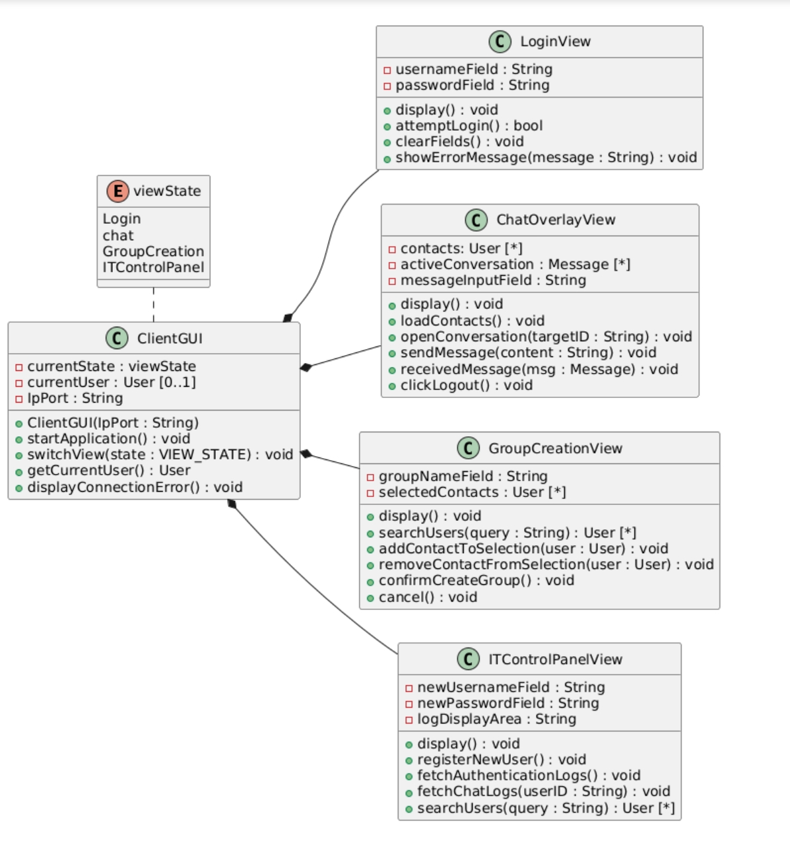

@startuml
left to right direction

' enumerations
enum viewState{
Login
chat
GroupCreation
ITControlPanel
}

' GUI main class
class ClientGUI {
- currentState : viewState
- currentUser : User [0..1]
- IpPort : String

+ ClientGUI(IpPort : String)
+ startApplication() : void
+ switchView(state : VIEW_STATE) : void
+ getCurrentUser() : User
+ displayConnectionError() : void
}

' sub classes
class LoginView {
- usernameField : String
- passwordField : String

+ display() : void
+ attemptLogin() : bool
+ clearFields() : void
+ showErrorMessage(message : String) : void
}

class ChatOverlayView{
- contacts: User [*]
- activeConversation : Message [*]
- messageInputField : String

+ display() : void
+ loadContacts() : void
+ openConversation(targetID : String) : void
+ sendMessage(content : String) : void
+ receivedMessage(msg : Message) : void
+ clickLogout() : void
}

class GroupCreationView {
- groupNameField : String
- selectedContacts : User [*]

+ display() : void
+ searchUsers(query : String) : User [*]
+ addContactToSelection(user : User) : void
+ removeContactFromSelection(user : User) : void
+ confirmCreateGroup() : void
+ cancel() : void
}

class ITControlPanelView {
- newUsernameField : String
- newPasswordField : String
- logDisplayArea : String

+ display() : void
+ registerNewUser() : void
+ fetchAuthenticationLogs() : void
+ fetchChatLogs(userID : String) : void
+ searchUsers(query : String) : User [*]
}

' relations of sub classes to main classes
ClientGUI *-down- LoginView
ClientGUI *-down- ChatOverlayView
ClientGUI *-down- GroupCreationView
ClientGUI *-down- ITControlPanelView
ClientGUI .left. viewState

@enduml

Log Class Diagram

PlantUML Editor

RPBVQeCm6CNl0tc7tArbhW_Ggufc8jXP4XtiIiHcBg1HujUBCVRkon-B3ajkajy9tpadv3H1hU7MTnXruXC834JBzWl8LMhHW1mKHXWz4Q5klT2r1HD6zaIweIs-Hq5-C28aovFqhU9b557E5_0QfXcDvtDU5dPtOUbxMD3gR6w62RKeONbvMGF-mGjwhYXZESFersRmg-dgQIBPq7hR5mAo5wP3Fv8ZYMiGCpN1xANZFQN7ar1NeTFOS0vQgjPZqrIEKYZOACsWmF0LjVpP1jXjF8Bj_E3Xx60pT-_7jWAAUv_TVjN8IPctSSAgbjFuxEp4fO7Js1BXaHpvBFyaz-AstC7zXiFYPzV9c9alymS0

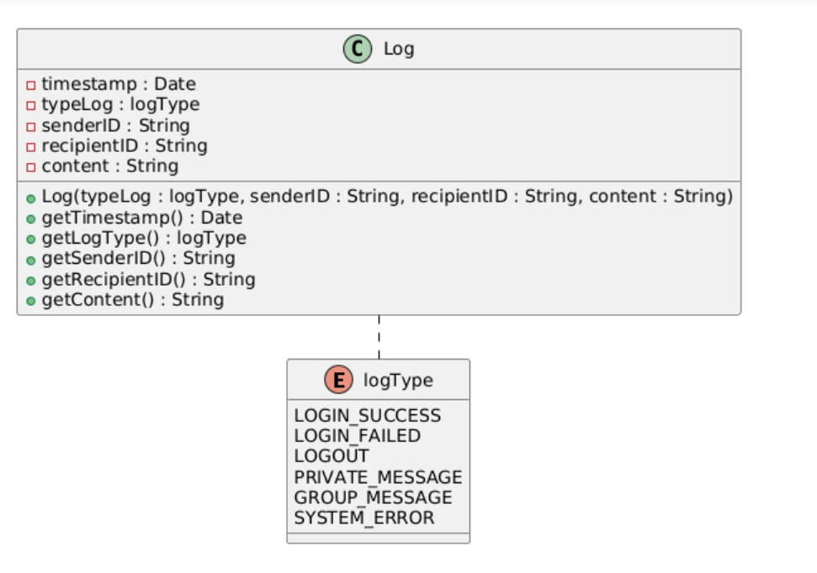

@startuml
left to right direction

' enumerations
enum logType {
LOGIN_SUCCESS
LOGIN_FAILED
LOGOUT
PRIVATE_MESSAGE
GROUP_MESSAGE
SYSTEM_ERROR
}

class Log {
- timestamp : Date
- typeLog : logType
- senderID : String
- recipientID : String
- content : String

+ Log(typeLog : logType, senderID : String, recipientID : String, content : String)
+ getTimestamp() : Date
+ getLogType() : logType
+ getSenderID() : String
+ getRecipientID() : String
+ getContent() : String
}

Log .right. logType

@enduml

NetworkServer Class Diagram

PlantUML Editor

RL9DJyCm3Br7od_8ZGx6VW2deMuJbM13BPmGXz2QBbAQJ8xR2-A_aoOPQWUds7xFB_vQEv98VQSvq_19Wgn0rHv9D0gX9cKDPvnT2J1z1oXZO7I40nm0AvBKko_EX3Zi7ulzDbYxtTdSbkMXvEnxLAcrT4vK8K-4bDkaKZoBEr4HAjF6yCaY-P0oDAN5ptnywaQ2zBKEa6i5XaP67Qstw_U8aoMfSsjCRCebxH6yIILbVsfPJkfOH6eOL-8lF39OrPmHU_eNqCeHcCdV5_W7MjdKqj4JE2TRo3hNUaBovboqFK52oBv8zC-SlnGKeiNcjusvn56QHgT9RPIhOrrP79XdHkGXi72UwcNlmvnV_QXosniAhQGj1RoQR2Q0yrM5EqWNi5fTW9ojmJJ-5dy0

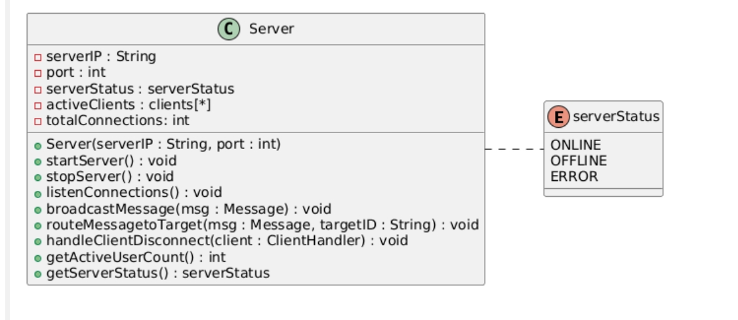

Network Client class diagrams

NP71JiCm38RlaV8ElgqJR0_0QT8G4WVGfF82fVLAj3IUOdSS4EzE4hVLoYt-lp-_xUJ0qaGP1s-DnxE044JNVmbqBc8hZe8rrcm0mpXWRB80PuhGKWZA8IN8oDcMJLC9FzO07DM5NIxWsN4x2s3DhoRJcDAymo0GKBufNbpe8RFMDynmBEnTaSRkW37UCBwUu0bgYUd2lNoYA0cu8AfgUatj1REkX-c23fjJvYK07jOzAtTTsZp2TGdVgdTQwOFgqhpQ9lf9v9Lsoyu5tCXr2XX3zuRCJO_Lm7rYKxMsUSU2uONYHFbVJ8-YenTztg8yhJNhfzllxxxgaDgNN_y3

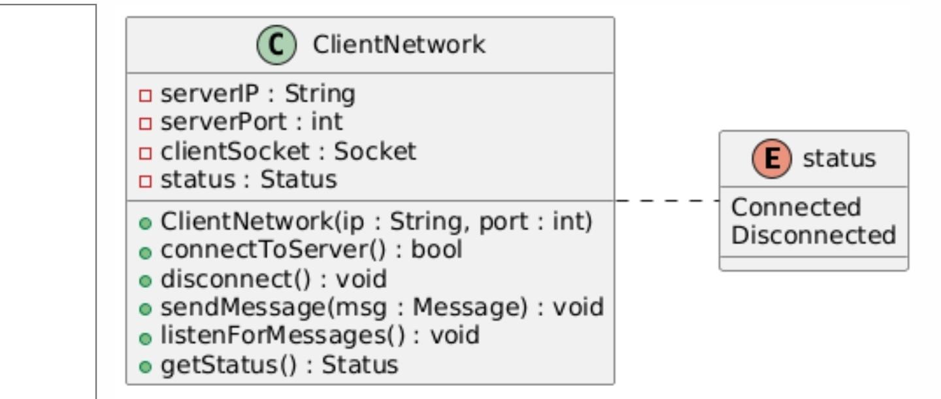

@startuml
left to right direction

' enumeration for connection status

enum status {
Connected
Disconnected
}

' our client networking

class ClientNetwork {
- serverIP : String
- serverPort : int
- clientSocket : Socket
- status : Status

+ ClientNetwork(ip : String, port : int)
+ connectToServer() : bool
+ disconnect() : void
+ sendMessage(msg : Message) : void
+ listenForMessages() : void
+ getStatus() : Status
}

ClientNetwork .. status

@enduml

